The three authors of the article "The Network" (https://theintercept.com/2016/07/13/training/) were

Douglas Gillison, Nick Turse, Moiz Syed
July 13 2016, 10:00 a.m.

But you can be sure Glenn Greenwald was muchly involved.

Glenn Greenwald On His Resignation From The Intercept

The Pulitzer winner founded the Intercept to challenge official narratives and protect editorial freedom. When editors abandoned those principles, spiking a controversial story, he was forced to quit
Matt Taibbi | Oct 29 | 825 | 986
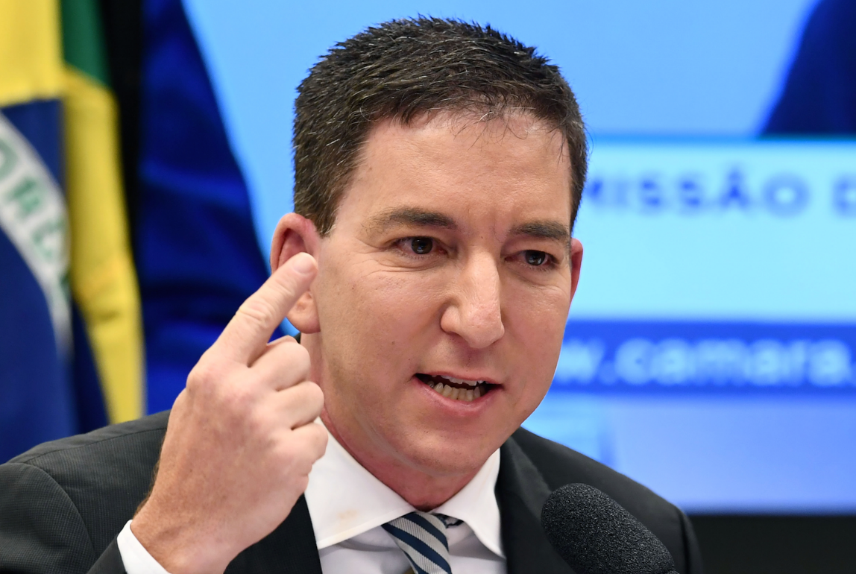
Pulitzer Prize-winning journalist Glenn Greenwald quit his job this morning. In a bizarre, ironic, and disturbing commentary on trends in modern media, the celebrated reporter was forced to resign after writing a story criticizing both the Biden campaign and intelligence community — only to have it spiked by the editors of The Intercept, the news outlet he co-founded six years ago with the aim of preventing pretty much this exact situation.

https://taibbi.substack.com/p/glenn-greenwald-on-his-resignation

https://en.wikipedia.org/wiki/Glenn_Greenwald

https://www.nytimes.com/2020/10/29/business/media/glenn-greenwald-leaving-intercept.html

Glenn Greenwald Leaves The Intercept, Claiming He Was Censored
Mr. Greenwald will join other high-profile journalists who have left major media outlets to work largely on their own at Substack.
……………….

https://theintercept.com/2020/10/29/glenn-greenwald-resigns-the-intercept/

GLENN GREENWALD RESIGNS FROM THE INTERCEPT

Greenwald’s decision stems from a fundamental disagreement over the role of editors and the nature of censorship.

Betsy Reed
October 29 2020, 3:32 p.m

